AFRICAN SOLIDARITY CIVIC ORGANISATION NPC (ASCO)
Monitoring Evaluation and Impact Framework
BOARD-APPROVED FINAL DOCUMENTATION
FINAL DOCUMENTATION — BOARD APPROVED; EXECUTION / FILING DETAILS TO BE RECORDED
This document records the Board-approved ASCO governance model and policy position. Legal effectiveness, execution, statutory-register updates and filing or registration requirements must be completed by the authorised persons and recorded in the approval register. The Memorandum of Incorporation remains subject to the Companies Act 71 of 2008 and applicable filing requirements.
DOCUMENT CONTROL
Version: 1.0 | Prepared and Board-approved: 10 September 2026 | Resolution reference: To be entered in the approval register | Effective date: To be recorded where applicable | Next review: To be recorded
1. PURPOSE
This framework distinguishes inputs, activities, outputs, outcomes and verified impact. Planning targets must not be presented as completed results.
2. INDICATORS
Level | Examples | Evidence
Inputs | Funding, staff, volunteers, partners | Budgets, approvals, agreements
Activities | Dialogues, exchanges, campaigns, workshops | Plans, registers, reports
Outputs | Participants, sessions, referrals, partnerships | Attendance, materials, registers
Outcomes | Knowledge, attitudes, dialogue, community action | Pre/post tools, feedback, follow-up
Safeguarding | Complaints, incidents, response and corrective action | Secure incident and complaints records

3. PROGRAMME TARGETS
Youth exchange: planning target of at least one annual exchange, at least 50 participants, at least two reciprocal countries where feasible and three learning insights per participant, subject to approval, resources, safeguarding and partners. Other targets in the Institutional Profile remain proposed unless Board-approved.
4. REPORTING
Every public result must have an as-at date, evidence owner, underlying records and consent-cleared materials. Posters and announcements are communications evidence, not proof of completed delivery.
5. REVIEW
The Executive Director prepares reports; the Board reviews performance and approves formal impact reporting.

Place of approval / execution: 49 Rif Road, Manor Gardens, Durban, KwaZulu-Natal, 4001, South Africa
BOARD APPROVAL SIGNATURES
The following signatures are copied from the signed ASCO documents supplied for this purpose. They record Board approval/acknowledgement in the stated capacities; statutory effectiveness, filing and authority remain subject to the applicable approval and filing process.
CHAIRPERSON / FOUNDER  Ms Busisiwe Makhosi Shandu    Date: 6 September 2026  Signature copied from supplied signed document | DIRECTOR: ICT AND COMMUNICATIONS  Mr Thapelo Nelson Maqalika  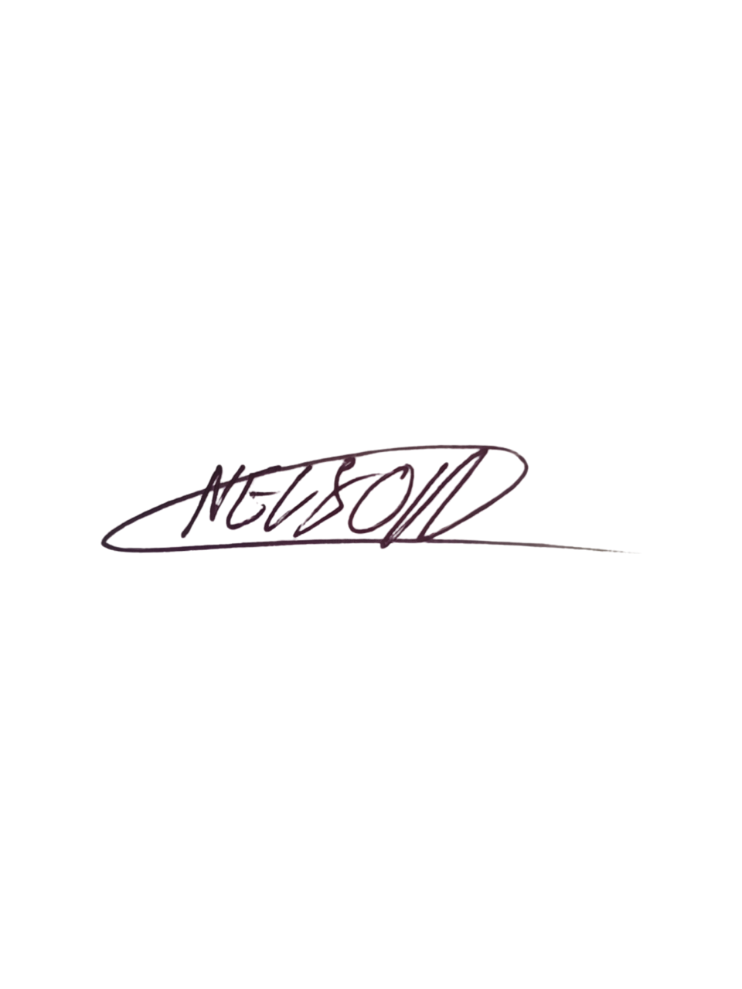  Date: 6 September 2026  Signature copied from supplied signed document
EXECUTIVE DIRECTOR  Mr Bhekisisa Shandu  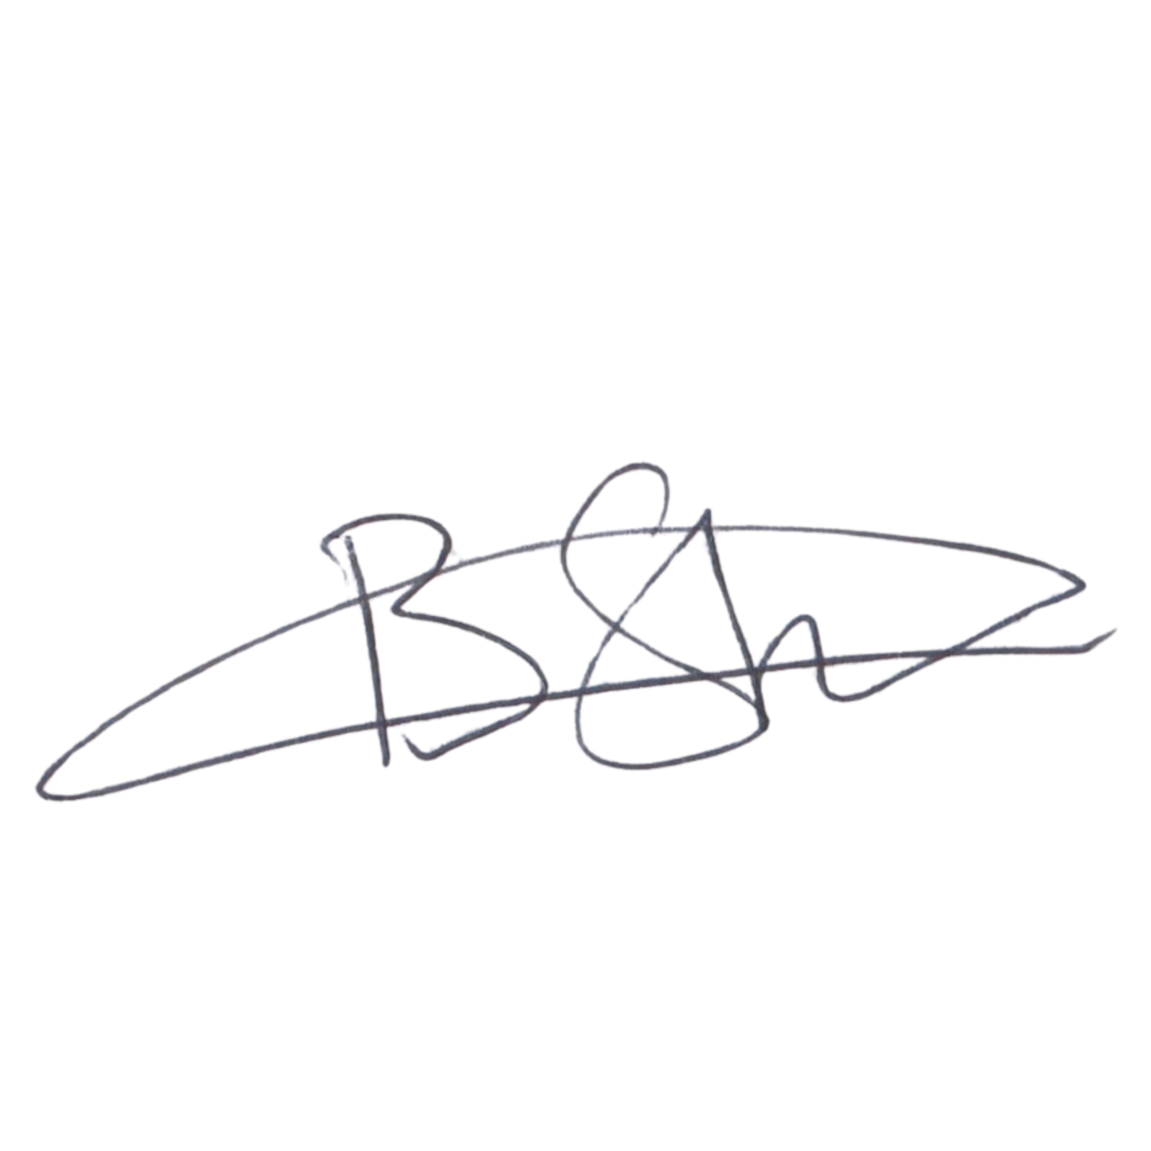  Date: 6 September 2026  Signature copied from supplied signed document | DIRECTOR: PEOPLE AND CULTURE / FINANCE AND PROCUREMENT  Mr Khulekani Gumede  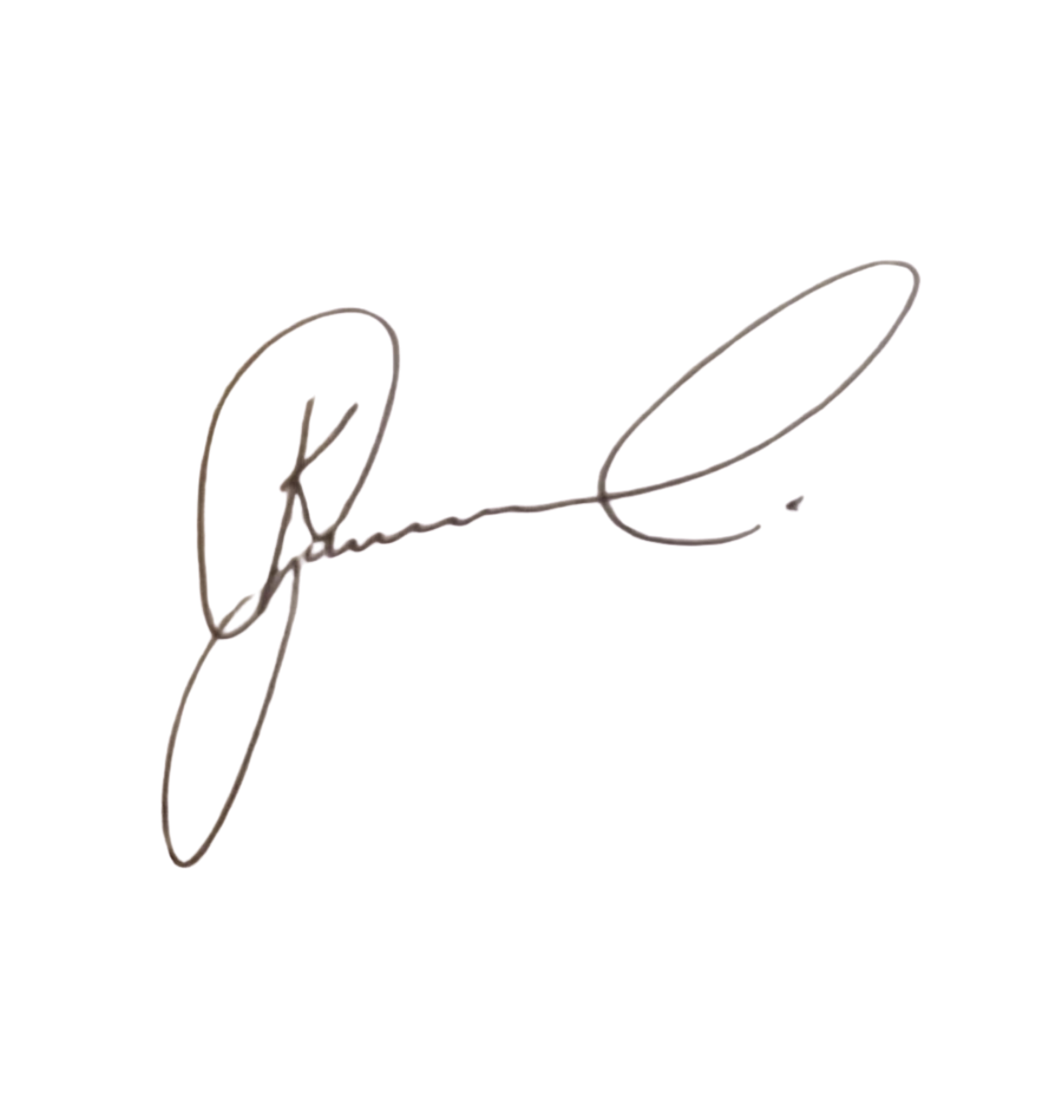  Date: 6 September 2026  Signature copied from supplied signed document

